TRAFFIC FLOW MANAGEMENT SYSTEM

>Team Details
-Jake Mathew (122301015)
-Hemanth (122301018)
-Ajaykumar (112301021)
-Aravind K (112301017)
-Ruthvi M (142301021)

>How the User’s need is identified:
As a result of rapid urbanization and the booming population. The number of vehicles on the road have exponentially Increased and this brings forward a lot of problems with the existing infrastructure of a city.
An efficient multi-mode transportation system will be needed as the population grows. Heavy traffic jams, traffic infractions, car accidents, and a disjointed transportation system will be a burden for the expanding population as a result of the city's unplanned infrastructure.
This problem brings up the idea of an intelligent traffic management system (ITMS).

>Details of research conducted on the problem
I have conducted comprehensive research on the traffic flow management system problem aiming to address the challenges associated with the modern traffic management systems in urban areas.
The study was conducted by analysing and comparing all the present traffic management systems their efficiency and drawbacks to try and create a more efficient system.
Most of the analysis was conducted using the research journals published on the very same topic.

>Details of the solution already present
There are two main types: fixed time and dynamic control.
Fixed time traffic signals use a timer to change the lights at a fixed interval. They could be as short as 30 seconds or as long as several minutes, depending on the intersection’s historical traffic data. These traffic lights use an electro-mechanical signal controller, which has movable components and a dial timer. This allows the light to switch and hold light colours for the predetermined amount of time.
Dynamic traffic light control systems work by adapting their timing to current traffic conditions. They use a detector, which can communicate with the traffic light control system to let them know about current traffic. When an intersection is jammed, they’ll adjust timing to let traffic flow better.

>Problem Definition
Creating an intelligent traffic flow management system.
An intelligent traffic flow management system is a system designed to reduce congestion on the roads using sensors and machine learning.
>Possible Solutions with merits and demerits
1.Using geomagnetic data collector and data receiver: The data collector uses the vehicle detector embedded in it to detect passing vehicles and sends the data over to a central network using Lan. Then using the weekly similarity characteristics of traffic flow data, and the method of weighting the historical data and modifying the time series prediction model to make a short-term traffic flow prediction and customise the traffic lights based on it.
Merits: A lot of computational power is not needed.
The cost of implementing and managing it is less

Demerit: Will not work in case of an irregularity from the predicted
model

2.With the help of the users: The vehicle concentration or density will be detected by the IR LEDs and photodiodes. The controller will take the data from IR communication taking place in between IR Transmitter and IR Receiver. The microcontroller Arduino nano will process this received data and show the signals through red, yellow and green LED’s along with that controller will also ensure the delivery of the sensor data to users in form of a user-friendly website where the people could watch the live traffic status. user will click on opening a specific lane i.e., turning the green signal for that specific lane, the microcontroller will stop taking the data from IR Communication and will open the requested lane by showing the green signal.

Merits: Users will have more control because of which efficiency is
Will increase
People need not wait till the system detects the start of a
Congestion

Demerits: Highly prone to hacking
Can become a very tedious affair for people to manually
change the lights
Can possibly end up causing more confusion
>Detail of solution selected for prototyping

The System will pass a screenshot from a CCTV at an intersection for real time traffic density calculation using image processing and computer vision at regular intervals. Then by using a customised machine learning model we detect the number of vehicles present in that lane. The algorithm then will use this traffic density and set appropriate time for each green and red signals present in the intersection.
I will be using the yolo algorithm in tensor flow framework for object detection in the snapshots we have obtained from the CCTV.
Yolo (You only look once) is an end-to-end neural network that makes prediction of bounding boxes and class probabilities all at once.
TensorFlow is an end-to-end open-source deep learning framework developed by google in 2015 that helps implement data automation, model tracking.
The Arduino-controlled CCTV will be sending snapshots to the computer in regular intervals.
The traffic density obtained from the yolo algorithm can be used in the formulas for calculating time for each traffic light.
And these values will be returned back to the Raspberry pi to control the timings of the traffic lights.

>Sketching and prototyping
Prototype of the Computer connected to a camera for capturing snapshots
Here I will be using a ESP32 cam to imitate the CCTV snapshots so as to reduce the cost of the prototype.
ESP32 CAM
FTV ADAPTER

ML Code
Simulation

>Bill of the materials
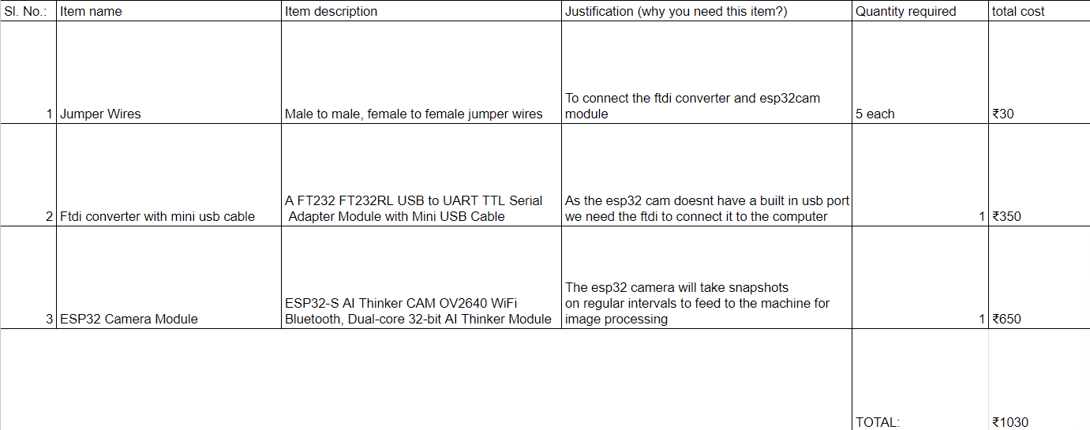
>Tests Conducted
As part of our test, we set up a Esp32 camera in front of a Unity simulation that ran a simple traffic simulator that we had built in C#. Regularly taking pictures with the esp32 camera, we wrote a program to send the photos to a folder on the computer using a Google API. Then, using machine learning code written in Python, the computer would read the images and calculate a basic wait time based on the number of cars on a lane. This value will be entered into a text file, which the Unity simulation will read when it detects fresh text inserted. It will then cause the traffic light in that lane to become green for that duration of time. This technique is repeated incessantly.
This was a means of demonstrating the potential viability of our projects without requiring them to be scaled up.

Link To the Video
https://drive.google.com/drive/folders/1pTqXDE1XTEWiO4XKTBDfBne95rY0LtQX?usp=drive_link

>Extra details
A snapshot of the simulation in unity
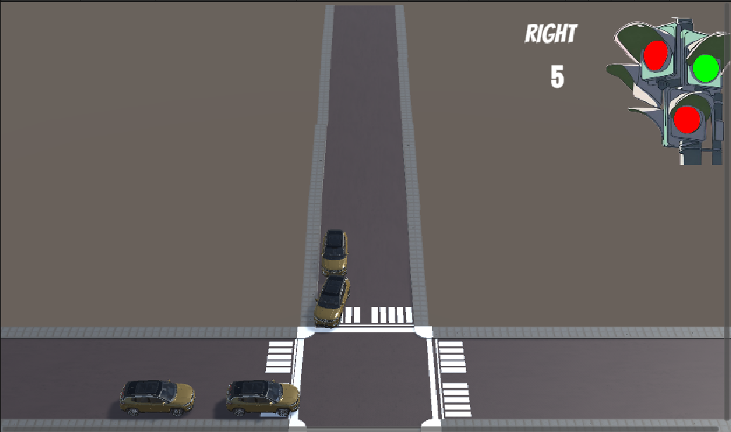

The link to the scripts used for the project
https://github.com/Whackerfin/Traffic-Simulator/tree/main

